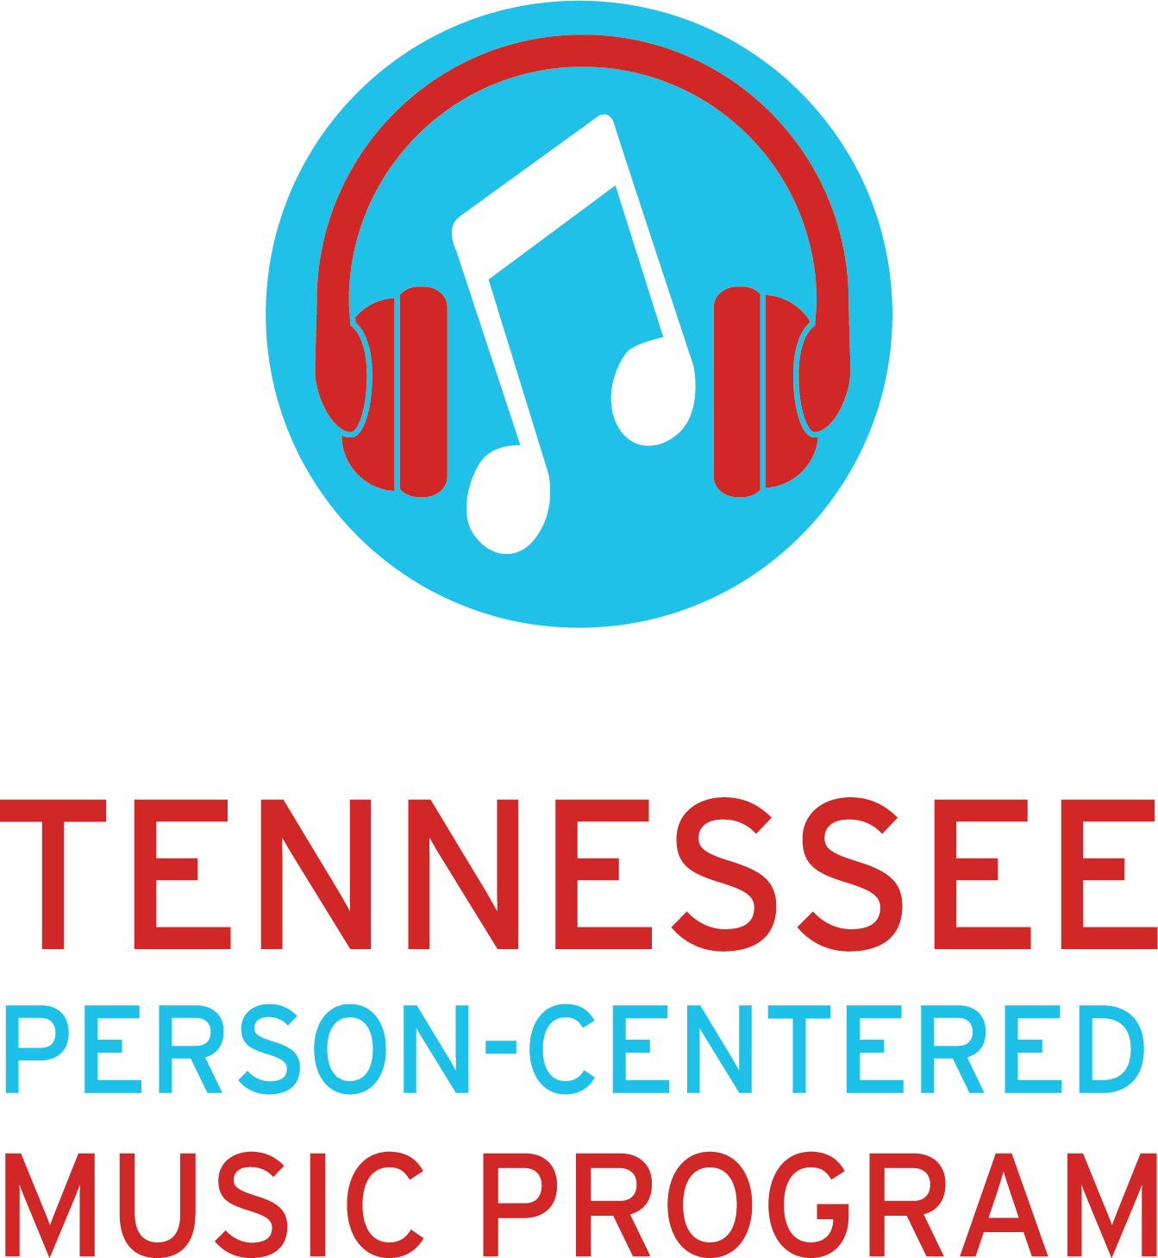
Script for Contacting Family Members and Caregivers
Greeting
Good morning/Good afternoon, may I speak with (insert family member/caregiver’s name) please?
If YES: If NO: May I leave a message for them?
Introduction
If Program Coach:
My name is __________________________. I am a Program Coach for the Tennessee Person-Centered Music Program that is being offered at (insert name of nursing home). Is now a good time to talk?
If Volunteer: My name is __________________________. I am a Volunteer for the Tennessee Person-Centered Music Program that is being offered at (insert name of nursing home). Is now a good time to talk? (Insert name of Program Coach) called you earlier to tell you a little bit about the program and said I would be calling to answer any questions you had about it and to ask some questions about (insert resident’s name)’s musical preferences.
Is now a good time to talk?

If YES:
The Tennessee Person-Centered Music Program is a program geared towards providing nursing home residents in Tennessee with a therapeutic music intervention through the use of personalized playlists on headphones to improve the quality of life and other healthy outcomes. The nursing homes select what we call “Program Coaches” who will be our primary contact at each facility. All coaches have gone through our training and know when the best times to administer music to residents, but the residents can ask for their music whenever they want it and if you are at the nursing home and think (insert name of resident) might want to listen to (his/her) music, just let one of the nursing staff know. Nursing homes have external hard drives to serve as a ‘music library’ to store all music for enrolled residents. Nursing homes also use wireless Bluetooth speakers for assisting residents with activities of daily living, like bathing and dressing when headphones cannot be worn. They can also be used for you to listen to music together during visits (when able). Do you have any questions about the program?

If NO:
If you have any questions, feel free to contact (insert name of nursing home)’s program coach, (insert name of program coach). (He/She/They) should be able to answer them.

Ok, are you ready to answer some questions about (insert name of resident)?
If YES: I’ll start with an easy one. What year were they born?
(Ask them the questions on the Assessment of Musical Preferences (Gerdner et al., 2000). When finished, ask them:
Do they wear hearing aids or have trouble hearing?
If YES: Make sure to let the program coach that the resident might need headphones during the music session.
Have they been impacted during the pandemic?
If family member discusses visitation, ask:
Did they respond well during virtual visitation with you through phones, tablets, or iPads?
(These questions will give you an idea about how the resident might respond during your music sessions.)

Based off of the answers you have given me, I will go through what we call a “Music Discovery” which is a deep dive into the music of the artists you recommended and preferred genres. From there I will put together music to play for (insert name of resident) and we will start a series of music sessions. Music sessions are used to help us create their personalized playlist by finding which songs they respond the best to. After we have between 30 and 50 songs for (his/her/their) personalized playlist, we purchase those songs, download them, put them on a micro-SD card that is installed in their designated headphones. After their headphones are pre-loaded with their music, residents can begin listening to their music anytime they want or as needed!

Do you have any other questions?
If Yes: If you would like more information about the Tennessee Person-Centered Music Program, there is more information about the program on the TPCMP website. The website is https://tnpersoncenteredmusic.org/ . There is a lot of great information on the TPCMP website, so it should be able to answer any questions you have!
If No: Thank you so much for your time. Have a great day! Bye!

